Key Question: Who are you and can we be friends?  Key Skills –  Be able to engage in a back and forth conversation  Understand routines and expectations of the setting  Understand why questions  Be confident to speak to all adults in school  Form positive relationships and play with others  Be able to use scissors correctly  Be able to write their name and some taught letter sounds accurately  To spell words orally using taught letter sounds accurately  Perform to a larger group with confidence (personal passports) | Previous Learning  During this half term we recognise that children come to our setting from various starting points and having had various experiences. We will use this term to observe, interact and build relationships with children. Liaising with previous settings and parents to gain a rounded view of each child’s previous experiences. | Key Vocabulary  School  Friends  Classroom  Routine  Autumn  Family  Special  Differences  Changes  Weather
Core Texts  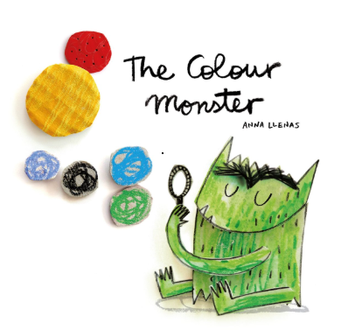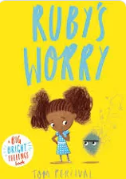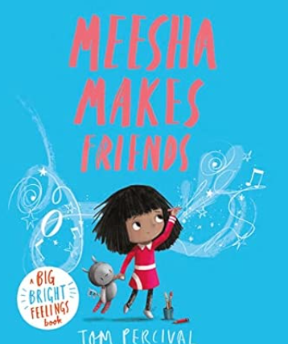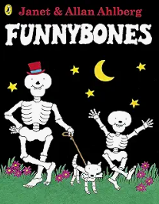  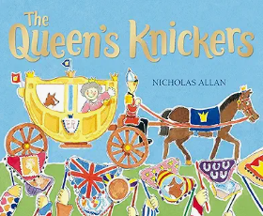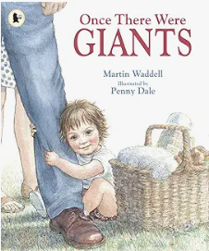 | Drawing Club  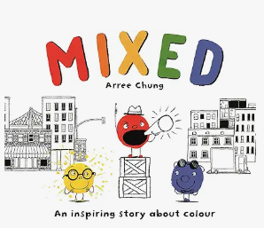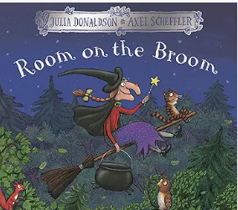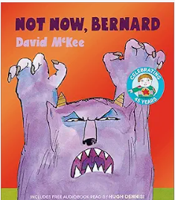 | Poems  Chop Chop  Pointy Hat  Falling Apples  A Basket of Apples  Leaves are Falling
Communication and Language | Personal, Social and Emotional Development | Physical development
Understand a question or instruction that has two -three parts.  Understand ‘why’ questions and often respond appropriately.  Know many rhymes and be able to talk about familiar stories with confidence  Use a wider range of vocab that which has been taught and more  Sing a large repertoire of songs | Sustained longer focus at chosen and directed activities  Express their feelings  Manage their own personal hygiene  Begin to find solutions to conflicts. For example, accepting that not everyone can be Spiderman in a game.  Remember rules without needing an adult to remind them  Be able to share and take turns with minimal adult intervention  Develop confidence in front of larger groups (personal passport) | Revise and refine the fundamental movement skills they have already required:  Rolling  Crawling  Walking  Jumping  Running  Hopping  Skipping  Climbing  Use core muscle strength to achieve a good posture when sitting at a table or on the floor.  Further develop the skills they need to manage the school day successfully e.g. lining up/ mealtimes  Continue to develop scissor control  Hold a pencil in a dominant hand and use it to write their name correctly.
Literacy | Mathematics | Understanding of the World
Read individual letters by saying the sounds for them. Engage in extended conversations about stories learning new vocabulary.  Use some of their print and letter knowledge in their early writing  Write their name  Write some letters accurateky.  To spell words orally using taught letter sounds  Hear initial sounds in words and write the letters to match e.g. c – cat, d – dog  Begin to write words  Begin to blend CVC words | Recite numbers to 5  Sing number rhumes to 5  Make patterns with colours  Sequence 3 events linked to a familiar rhyme or story  Count to 5/10  Order numbers to 5/10  Sort objects into groups and explain how I have sorted them  Compare size, weight, height and capacity  Recognise and make AB patterns  Find and correct mistakes in patterns | Talk about and understand changes in their own lifetime by creating a personal timeline. Talk about things that have happened in their lifetime.  Look at baby photos – how have I changed since I was a baby? (Peepo)(Once we were giants)  Talk about and describe features of their own family and talk about families in other countries across the world (The Queens Knickers)  To explore talking about what happens first and next in my day.  - To talk about special events and celebrations in my own life. (personal passports  To talk about things that are important to me and my family (personal passport).  Seasonal changes - I can explore changes that happen around me. (Autumn walk)
Expressive Arts and Design | Key Experiences to be planned for
Portrait skills – drawing themselves. Observational work.  Explore musical instruments and the sounds they make.  Develop storylines in their pretend play.  I can explore making marks using a range of drawing tools.  I can explore drawing using my imagination and experiences.  I can explore joining materials together during play. | Bridgwater week – Carnival  Personal passports  Signs of Autumn walk  Investigation Thursdays

