
RSE
Parent guidance
Breakdown by year group
This document was last updated on 13.11.25
Contents:
EYFS - PSED overview | 3
Year 1 RSE | 4–10
Year 2 RSE | 11–17
Year 3 RSE | 18–23
Year 4 RSE | 24–32
Year 5 RSE | 33–40
Year 6 RSE | 41–48
FAQs | 49

EYFS - PSED overview
Personal, social and emotional development is one of the three Prime Areas in the Statutory framework for the early years foundation stage. The early learning goals (ELG) below summarise the knowledge, skills and understanding that all young children should have gained by the end of reception year. These are referenced in our Kapow Primary RSE & PSHE lesson plans, along with the relevant non-statutory Development Matters guidance.

ELG: Self regulation
Children at the expected level of development will:
- Show an understanding of their own feelings and those of others, and begin to regulate their behaviour accordingly.
- Set and work towards simple goals, being able to wait for what they want and control their immediate impulses when appropriate.
- Give focused attention to what the teacher says, responding appropriately even when engaged in an activity, and show an ability to follow instructions involving several ideas or actions.
Kapow Primary unit^{My feelings} : following instructionsKapow Primary unitListening and :

ELG: Managing self
Children at the expected level of development will:
- Be confident to try new activities and show independence, resilience and perseverance in the face of challenge.
- Explain the reasons for rules, know right from wrong and try to behave accordingly.
- Manage their own basic hygiene and personal needs, including dressing, going to the toilet and understanding the importance of healthy food choices.
Kapow Primary unit: Kapow Primary unit:
Taking on challenges My wellbeing

ELG: Building relationships
Children at the expected level of development will:
- Work and play cooperatively and take turns with others.
- Form positive attachments to adults and friendships with peers.
- Show sensitivity to their own and to others’ needs.
Kapow Primary unit: Kapow Primary unit: Special relationships My family and friends

How Kapow Primary's RSE scheme is structured
RSE Statutory guidance
(and non-statutory sex education)
Kapow Primary RSE scheme of work
Kapow Primary key areas - Key stages 1 and 2
Family and Health and Safety and the relationships wellbeing changing body
Which RSE statutory requirements are we working towards in Year 1?
Kapow Primary's RSE scheme takes a spiral approach to the curriculum and therefore these areas will be revisited and further developed in the subsequent year group.
Families and people who care about me:
- Families are important for children growing up because they can give love, security and stability.
- The characteristics of healthy family life, commitment to each other, including in times of difficulty, protection and care for children and other family members, the importance of spending time together and sharing each other’s lives.
Caring friendships:
- How important friendships are in making us feel happy and secure, and how people choose and make friends.
- The characteristics of friendships, including mutual respect, truthfulness, trustworthiness, loyalty, kindness, generosity, trust, sharing interests and experiences and support with problems and difficulties.
- That healthy friendships are positive and welcoming towards others, and do not make others feel lonely or excluded.
Respectful relationships:
- Practical steps they can take in a range of different contexts to improve or support respectful relationships.
- The importance of self-respect and how this links to their own happiness.
- What a stereotype is, and how stereotypes can be unfair, negative or destructive.
Being safe:
- Each person’s body belongs to them, and the differences between appropriate and inappropriate or unsafe physical, and other, contact.
- How to respond safely and appropriately to adults they may encounter (in all contexts) who they do not know.
- How to recognise and report feelings of being unsafe or feeling bad about any adult.
- How to ask for advice or help for self and for others, and to keep trying until they are heard, including having the vocabulary and confidence to report concerns or abuse.
Year 1: How is RSE covered in Kapow Primary’s RSE lessons?
Strands within the Kapow Primary scheme will explore the following topics and concepts:

Families and relationships:
- Exploring how families can be different.
- Characteristics and impact of positive friendships.
- Learning that issues can be overcome.
- People show feelings differently.
- Issues around stereotyping.
Safety and the changing body:
- Learning how to respond to adults in different situations.
- Distinguishing appropriate and inappropriate physical contact.
Health and wellbeing:
- Exploring personal qualities.
- Strategies to manage feelings.

How is my child taught about puberty and human reproduction?
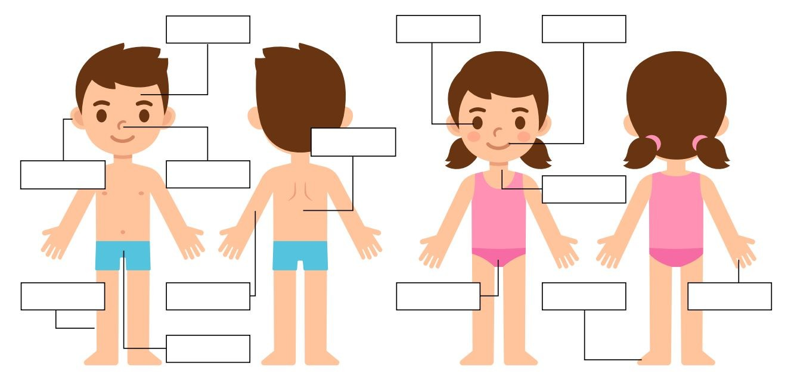
Each year group will be taught at an appropriate level for their age and developmental stage, building on the previous years’ learning.
Children of ages 5–7 are taught:
- Acceptable and unacceptable physical contact.
- The differences between boys’ and girls’ bodies.
- Scientific names for body parts (mixed-age lessons will also include the teaching of the following body part names: penis, vagina and vulva.)
All lessons are taught using the correct, scientific terminology, child-friendly language and diagrams.

RSE updates specific to Year 1 (sexual harassment)
Kapow Primary’s approach to addressing sexual harassment in schools builds on the statutory requirements of the RSE curriculum and the outcomes from the Department for Education’s statutory Keeping Children Safe In Education 2023 document.
Kapow Primary’s RSE & PSHE curriculum covers boundaries, respectful relationships, permission seeking and giving in relationships and reporting concerns in line with the Relationships and sex education and Health Education guidance.
In Year 1, the appropriate areas are covered in the following lessons:
- To begin to understand that being friendly to others makes them feel welcome and included.
- To begin to understand what is meant by a stereotype.
- To begin to understand the difference between acceptable and unacceptable physical contact.

Top tips: How to help at home
- Listen to your child's joys, concerns and worries without judgement and spend time with them talking about life in and outside of school.
- Model the appropriate language for body parts, reinforcing the terminology taught within school.
- Remind children that appropriate contact should make a person feel cared for and important. Explain that it might also include touch that hurts or is uncomfortable, but these instances should only be to keep the person safe and healthy (e.g. getting an injection, or pulling someone back from a passing car).
- Encourage children to communicate any unwanted touches. For example, respect their wishes if they say they do not want to be kissed, cuddled or tickled, or ask someone to stop. Showing children that their boundaries are respected is an important part of them understanding how to respect others.

How Kapow Primary's RSE subject is structured
RSE Statutory guidance
(and non-statutory sex education)
Kapow Primary RSE scheme of work
Kapow Primary key areas - Key stages 1 and 2
Family and Health and Safety and the relationships wellbeing changing body
Which RSE statutory requirements are we working towards in Year 2?
Kapow Primary's RSE scheme takes a spiral approach to the curriculum and therefore these areas will be revisited and further developed in the subsequent year group.
Families and people who care about me:
- Families are important for children growing up because they can give love, security and stability.
- Others’ families, either in school or in the wider world, sometimes look different from their family, but that they should respect those differences and know that other children’s families are also characterised by love and care for them.
- Stable, caring relationships, which may be of different types, are at the heart of happy families, and are important for children’s security as they grow up.
- Marriage represents a formal and legally recognised commitment of two people to each other which is intended to be lifelong.
Caring friendships:
- Healthy friendships are positive and welcoming towards others, and do not make others feel lonely or excluded.
- How to recognise who to trust and who not to trust, how to judge when a friendship is making them feel unhappy or uncomfortable, managing conflict, how to manage these situations and how to seek help or advice from others, if needed.
Respectful relationships:
- Practical steps they can take in a range of different contexts to improve or support respectful relationships.
- The conventions of courtesy and manners.
- What a stereotype is, and how stereotypes can be unfair, negative or destructive.
Online relationships:
- People sometimes behave differently online, including by pretending to be someone they are not.
- The same principles apply to online relationships as to face-to-face relationships, including the importance of respect for others online including when we are anonymous. Being safe:
- About the concept of privacy and the implications of it for both children and adults; including that it is not always right to keep secrets if they relate to being safe.
- Each person’s body belongs to them, and the differences between appropriate and inappropriate or unsafe physical, and other, contact.
- How to recognise and report feelings of being unsafe or feeling bad about any adult.
- How to ask for advice or help for self and for others, and to keep trying until they are heard, including having the vocabulary and confidence to report concerns or abuse.
- How to report concerns or abuse, and the vocabulary and confidence to do so.
- Where to get advice from e.g. family, school and/or other sources.
Year 2: How is this covered in Kapow Primary’s PSHE and RSE lessons?
Strands within the Kapow Primary scheme will explore the following topics and concepts:
Families and relationships:
- Learning that families are composed of different people who offer each other care and support.
- How other people show their feelings and how to respond.
- Looking at conventions of manners and developing an understanding of self-respect.
Safety and the changing body:
- Introduction to online safety.
- Distinguishing secrets from surprises.
- Naming body parts and looking at the concept of privacy.
How is my child taught about puberty and human reproduction?
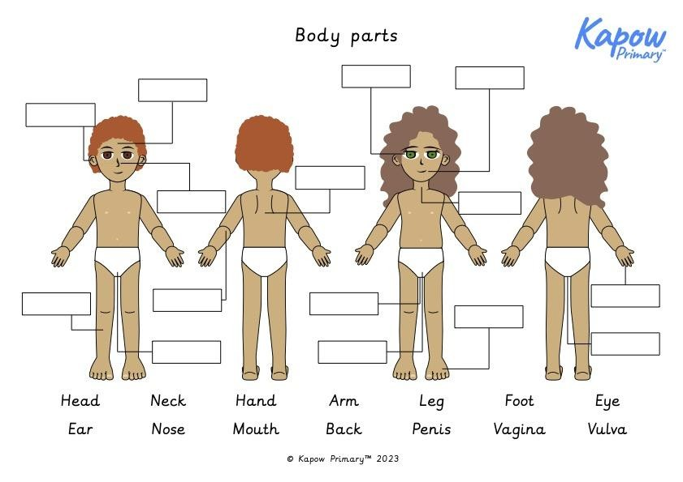
Each year group will be taught at an appropriate level for their age and developmental stage, building on the previous years’ learning.
Children aged 6–7 will:
- Learn about 'boys’ and girls’ bodies.
- Scientific names for body parts.
- Understand that private parts are private.
All lessons are taught using the correct, scientific terminology, child-friendly language and diagrams.

RSE updates specific to Year 2 (sexual harassment)
Kapow Primary’s approach to addressing sexual harassment in schools builds on the statutory requirements of the RSE curriculum and the outcomes from the Department for Education’s statutory Keeping Children Safe In Education 2023 document.
Kapow Primary’s RSE & PSHE curriculum covers boundaries, respectful relationships, permission seeking and giving in relationships and reporting concerns in line with the Relationships and sex education and Health Education guidance.
In Year 2, the appropriate areas are covered in the following lessons:
- To begin to understand that some friendships might make us feel unhappy and how to deal with this.
- To develop an understanding of stereotypes and how these might affect job/career choices.
- To begin to understand the difference between secrets and surprises.
- To begin to understand the concept of privacy and the correct vocabulary for body parts.
- To understand safe and unsafe touches.

Top tips - How to help at home
- Through your words and tone, welcome your child’s curiosity for new activities and interests. Ask gentle questions to see what your child already knows, before adding new information. Don’t assume that they know things because they use certain words. If you don’t have the answer to your children’s questions, it’s OK to say that you don’t know but will find out.
- Take time to play the online games your children like to play so that you can understand the features. You can find out if there is anything concerning you need to be aware of, such as safety features or parental controls which should be enabled.
- Use appropriate language for body parts at home so it reinforces what is taught at school.
- Remind your child that their body is their own and they don’t have to let anyone touch it in a way that is unsafe and/or unwanted. Everyone else also has that right. This is the beginning of giving a child control over their body and teaching them about consent.

How Kapow Primary's RSE subject is structured
RSE Statutory guidance
(and non-statutory sex education)
Kapow Primary RSE scheme of work
Kapow Primary key areas - Key stages 1 and 2
Family and Health and Safety and the relationships wellbeing changing body
Which RSE statutory requirements are we working towards in Year 3?
Kapow Primary's RSE scheme takes a spiral approach to the curriculum and therefore these areas will be revisited and further developed in the subsequent year group.
Families and people who care about me:
- Others’ families, either in school or in the wider world, sometimes look different from their family, but that they should respect those differences and know that other children’s families are also characterised by love and care for them.
- Stable, caring relationships, which may be of different types, are at the heart of happy families, and are important for children’s security as they grow up.
- How to recognise if family relationships are making them feel unhappy or unsafe, and how to seek help or advice from others if needed.
Caring friendships:
- Healthy friendships are positive and welcoming towards others, and do not make others feel lonely or excluded.
- How to recognise who to trust and who not to trust, how to judge when a friendship is making them feel unhappy or uncomfortable, managing conflict, how to manage these situations and how to seek help or advice from others, if needed.
Respectful relationships:
- The importance of respecting others, even when they are very different from them (for example, physically, in character, personality or backgrounds), or make different choices or have different preferences or beliefs.
- Practical steps they can take in a range of different contexts to improve or support respectful relationships.
- About different types of bullying (including cyberbullying), the impact of bullying, responsibilities of bystanders (primarily reporting bullying to an adult) and how to get help.
- What a stereotype is, and how stereotypes can be unfair, negative or destructive.
Online relationships:
- The same principles apply to online relationships as to face-to-face relationships, including the importance of respect for others online including when we are anonymous.
- The rules and principles for keeping safe online, how to recognise risks, harmful content and contact, and how to report them.
Being safe:
- How to ask for advice or help for self and for others, and to keep trying until they are heard, including having the vocabulary and confidence to report concerns or abuse.
Year 3: How is this covered in Kapow Primary’s PSHE and RSE lessons?
Strands within the Kapow Primary scheme will explore the following topics and concepts:
Families and relationships:
- How to resolve relationship problems.
- Effective listening skills and about non-verbal communication.
- Looking at the impact of bullying and what action can be taken.
- Exploring trust and who to trust and that stereotyping can exist.
Safety and the changing body:
- Be a responsible digital citizen.
- Cyberbullying, identifying unsafe digital content.
- Influences and making independent choices.

RSE updates specific to Year 3 (sexual harassment)
Kapow Primary’s approach to addressing sexual harassment in schools builds on the statutory requirements of the RSE curriculum and the outcomes from the Department for Education’s statutory Keeping Children Safe In Education 2023 document.
Kapow Primary’s RSE & PSHE curriculum covers boundaries, respectful relationships, permission seeking and giving in relationships and reporting concerns in line with the Relationships and sex education and Health Education guidance.
In Year 3, the appropriate areas are covered in the following lessons:
- To begin to understand the impact of bullying.
- To recognise that stereotypes are present in everyday life.

Top tips: How to help at home
- Find time to talk, just the two of you – ‘check in’ with them while you’re doing things together, so they get used to talking about their feelings.
- Play together – play helps children to be curious, learn new things, solve problems and express feelings without words.
- You can help your children learn how to deal with their emotions in a healthy way by modeling coping skills at home. You can engage in these skills with your child or talk them through doing them on their own. Activities such as deep breathing, using stress balls, art (painting, coloring, doodling) or going for walks can be great strategies for coping with feelings.
- Uncertainty about day-to-day schedules can lead to a lot of stress or anxiety in a child’s life. Creating a general routine at home can provide some relief and peace for your child, whether it’s a schedule for daily meals or a weekly movie night. Having clear boundaries is also important for your child to know what is expected of them at home and can minimise feelings of frustration from both parent and child.

How Kapow Primary's RSE subject is structured
RSE Statutory guidance
(and non-statutory sex education)
Kapow Primary RSE scheme of work
Kapow Primary key areas - Key stages 1 and 2
Family and Health and Safety and the relationships wellbeing changing body
Which RSE statutory requirements are we working towards in Year 4?
Kapow Primary's RSE scheme takes a spiral approach to the curriculum and therefore these areas will be revisited and further developed in the subsequent year group.
Families and people who care about me:
- The characteristics of healthy family life, commitment to each other, including in times of difficulty, protection and care for children and other family members, the importance of spending time together and sharing each other’s lives.
- Others’ families, either in school or in the wider world, sometimes look different from their family, but that they should respect those differences and know that other children’s families are also characterised by love and care for them.
- How to recognise if family relationships are making them feel unhappy or unsafe, and how to seek help or advice from others if needed.
Caring friendships:
- The characteristics of friendships, including mutual respect, truthfulness, trustworthiness, loyalty, kindness, generosity, trust, sharing interests and experiences and support with problems and difficulties.
- Healthy friendships are positive and welcoming towards others, and do not make others feel lonely or excluded.
Respectful relationships:
- The importance of respecting others, even when they are very different from them (for example, physically, in character, personality or backgrounds), or make different choices or have different preferences or beliefs.
- The conventions of courtesy and manners.
- The importance of self-respect and how this links to their own happiness.
- About different types of bullying (including cyberbullying), the impact of bullying, responsibilities of bystanders (primarily reporting bullying to an adult) and how to get help.
- What a stereotype is, and how stereotypes can be unfair, negative or destructive.
- The importance of permission-seeking and giving in relationships with friends, peers and adults.
Online relationships:
- How information and data is shared and used online.
Being safe:
- What sorts of boundaries are appropriate in friendships with peers and others (including in a digital context).
- About the concept of privacy and the implications of it for both children and adults; including that it is not always right to keep secrets if they relate to being safe.
- How to recognise and report feelings of being unsafe or feeling bad about any adult.
- How to ask for advice or help for self and for others, and to keep trying until they are heard, including having the vocabulary and confidence to report concerns or abuse.
Year 4: How is this covered in Kapow Primary’s PSHE and RSE lessons?
Strands within the Kapow Primary scheme will explore the following topics and concepts:
Families and relationships:
- Learning that families are varied and differences must be respected.
- Understanding physical and emotional boundaries in friendships.
- The roles of bully, victim and bystander.
- How behaviour affects others.
- Appropriate manners and bereavement.
Health and wellbeing:
- Developing emotional maturity.
- Learning that we experience a range of emotions and are responsible for these.
- Appreciating the emotions of others.
Safety and the changing body:
- Building awareness of online safety and benefits and risks of sharing information online.
- Difference between private and public.
- Age restrictions.
- Physical and emotional changes in puberty.
How is my child taught about puberty and human reproduction?

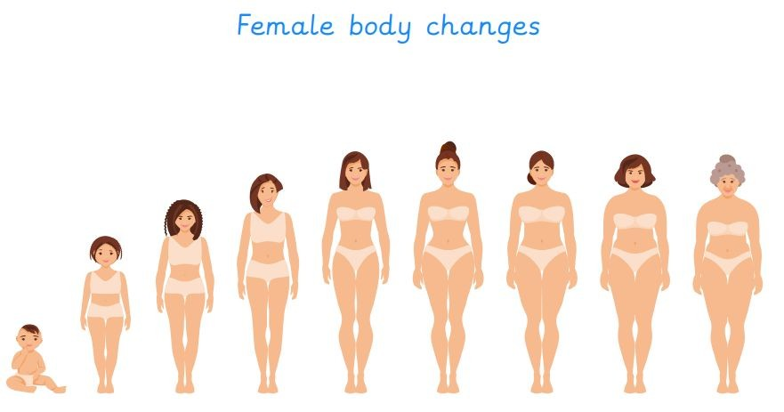
Each year group will be taught at an appropriate level for their age and developmental stage, building on the previous years’ learning.
Children aged 8–9 will:
- Learn about some of the physical changes pupils will experience as they go through puberty.
- Understand that physical change is part of growing up.
- Identify the changes that males and females go through as they grow and develop from being a child to an adult.

RSE updates specific to Year 4 (sexual harassment)
Kapow Primary’s approach to addressing sexual harassment in schools builds on the statutory requirements of the RSE curriculum and the outcomes from the Department for Education’s statutory Keeping Children Safe In Education 2023 document.
Kapow Primary’s RSE & PSHE curriculum covers boundaries, respectful relationships, permission seeking and giving in relationships and reporting concerns in line with the Relationships and sex education and Health Education guidance.
In Year 4, the appropriate areas are covered in the following lessons:
- To begin to understand the physical and emotional boundaries in friendships.
- To explore stereotypes in fictional characters and think about how these might influence us.

Top tips: How to help at home
- Children love to receive positive feedback and praise. Knowing they’ve done something well increases feelings of pride and confidence, which can stick with a child long-term. Providing positive reinforcement for behaviours will often encourage children to repeat that behaviour.
- Parental controls and privacy settings can help you manage how your child spends time online and help to keep them safe. Talk to your child before implementing any new settings and explain to them how different strategies can help to keep them safe.
- Show children it’s important to take care of their physical and mental health. Model good habits to them (e.g. “I can feel myself getting a bit wound up about that parking ticket again, so I’m going to have a walk/bath to calm myself down.”).
- Start talking with your child about relationships, body changes, and growing up from a young age. This helps to normalise conversations and build healthy habits.

How Kapow Primary's RSE subject is structured
RSE Statutory guidance
(and non-statutory sex education)
Kapow Primary RSE scheme of work
Kapow Primary key areas - Key stages 1 and 2
Family and Health and Safety and the relationships wellbeing changing body
Which RSE statutory requirements are we working towards in Year 5?
Kapow Primary's RSE scheme takes a spiral approach to the curriculum and therefore these areas will be revisited and further developed in the subsequent year group.
Families and people who care about me:
- Others’ families, either in school or in the wider world, sometimes look different from their family, but that they should respect those differences and know that other children’s families are also characterised by love and care for them.
- Marriage represents a formal and legally recognised commitment of two people to each other which is intended to be lifelong.
- How to recognise if family relationships are making them feel unhappy or unsafe, and how to seek help or advice from others if needed.
Caring friendships:
- How important friendships are in making us feel happy and secure, and how people choose and make friends.
- The characteristics of friendships, including mutual respect, truthfulness, trustworthiness, loyalty, kindness, generosity, trust, sharing interests and experiences and support with problems and difficulties.
- Most friendships have ups and downs, and that these can often be worked through so that the friendship is repaired or even strengthened, and that resorting to violence is never right.
Respectful relationships:
- The importance of self-respect and how this links to their own happiness.
- About different types of bullying (including cyberbullying), the impact of bullying, responsibilities of bystanders (primarily reporting bullying to an adult) and how to get help.
- What a stereotype is, and how stereotypes can be unfair, negative or destructive.
Online relationships:
- The rules and principles for keeping safe online, how to recognise risks, harmful content and contact, and how to report them.
- How to critically consider their online friendships and sources of information including awareness of the risks associated with people they have never met.
Being safe:
- How to recognise and report feelings of being unsafe or feeling bad about any adult.
- How to ask for advice or help for self and for others, and to keep trying until they are heard, including having the vocabulary and confidence to report concerns or abuse.
Year 5: How is this covered in Kapow Primary’s PSHE and RSE lessons?
Strands within the Kapow Primary scheme will explore the following topics and concepts:
Families and relationships:
- Developing an understanding of families, including marriage, of what to do if someone feels unsafe in their family.
- Issues can strengthen a friendship.
- Exploring the impact of bullying and what influences a bully’s behaviour.
- Learning to appreciate our attributes.
Safety and the changing body:
- Exploring the emotional and physical changes of puberty, including menstruation.
- Learning about online safety, influence.
- Strategies to overcome potential dangers.
How is my child taught about puberty and human reproduction?

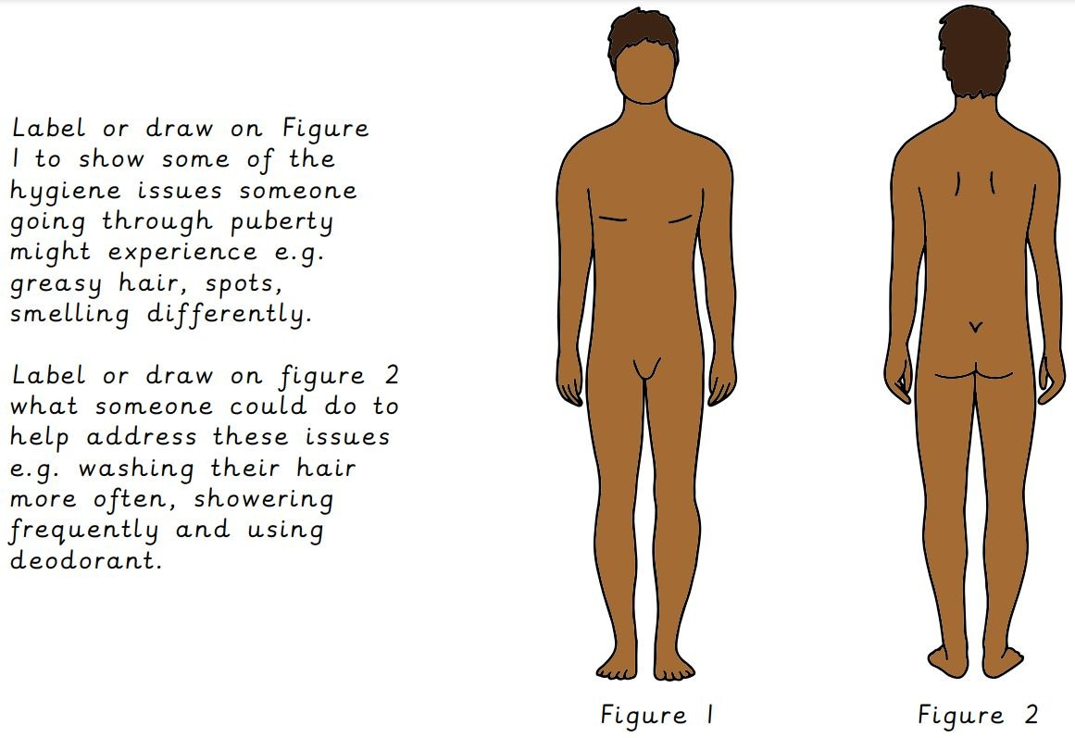
Each year group will be taught at an appropriate level for their age and developmental stage, building on the previous years’ learning.
Children aged 9–10 will learn about:
- The menstrual cycle and other changes that happen during puberty.
- Emotional changes that occur during puberty.

RSE updates specific to Year 5 (sexual harassment)
Kapow Primary’s approach to addressing sexual harassment in schools builds on the statutory requirements of the RSE curriculum and the outcomes from the Department for Education’s statutory Keeping Children Safe In Education 2023 document.
Kapow Primary’s RSE & PSHE curriculum covers boundaries, respectful relationships, permission seeking and giving in relationships and reporting concerns in line with the Relationships and sex education and Health Education guidance.
In Year 5, the appropriate areas are covered in the following lessons:
- To begin to understand some issues related to online friendships including the impact of their actions.
- To recognise how attitudes to gender have changed over time.

Top tips: How to help at home
- Make time and space to be able to give your child your full attention to share stories, have discussions and work through challenges.
- Explain that everyone is human and makes mistakes. Model effective ways to deal with difficult situations (e.g. calming down, saying sorry, explaining that you recognise you made a mistake and outlining what you will try to do better next time). They will learn from you that it is okay to make mistakes, build resilience and identify healthy ways to cope with emotions.
- Find ways to include your child in decision-making processes. This can help children feel that they are heard and valued. Something as simple as asking them whether they think you should prepare rice or pasta for dinner can show them they have a voice and give them the confidence to use it.

How Kapow Primary's RSE subject is structured
RSE Statutory guidance
(and non-statutory sex education)
Kapow Primary RSE scheme of work
Kapow Primary key areas - Key stages 1 and 2
Family and Health and Safety and the relationships wellbeing changing body
Which RSE statutory requirements are we working towards in Year 6?
Kapow Primary's RSE scheme takes a spiral approach to the curriculum and therefore these areas will be revisited and further developed in the subsequent year group.
Families and people who care about me:
- How to recognise if family relationships are making them feel unhappy or unsafe, and how to seek help or advice from others if needed.
Caring friendships:
- Most friendships have ups and downs, and that these can often be worked through so that the friendship is repaired or even strengthened, and that resorting to violence is never right.
Respectful relationships:
- Practical steps they can take in a range of different contexts to improve or support respectful relationships.
- In school and in wider society they can expect to be treated with respect by others, and that in turn they should show due respect to others, including those in positions of authority.
- What a stereotype is, and how stereotypes can be unfair, negative or destructive.
- The importance of permission-seeking and giving in relationships with friends, peers and adults.
Online relationships:
- People sometimes behave differently online, including by pretending to be someone they are not.
- The same principles apply to online relationships as to face-to-face relationships, including the importance of respect for others online including when we are anonymous.
Being safe:
- How to ask for advice or help for self and for others, and to keep trying until they are heard, including having the vocabulary and confidence to report concerns or abuse.
Year 6: How is this covered in Kapow Primary’s PSHE and RSE lessons?
Strands within the Kapow Primary scheme will explore the following topics and concepts:
Families and relationships:
- To resolve conflict, through negotiation and compromise.
- Respect.
- Understanding that everyone deserves to be respected.
- Grief.
Safety and the changing body:
- The reliability of online information.
- The changes experienced during puberty.
- How a baby is conceived and develops.
How is my child taught about puberty and human reproduction?
Each year group will be taught at an appropriate level for their age and developmental stage, building on the previous years’ learning.
Children aged 10–11 will:
- Further develop their understanding of the physical and emotional changes that happen during puberty.
- Learn about the biology of conception. (Parents have the right to withdraw their child from the 'Main event' part of this lesson.)
- Learn how a baby develops in the womb and is born. (Parents have the right to withdraw their child from the lesson.)

RSE updates specific to Year 6 (sexual harassment)
Kapow Primary’s approach to addressing sexual harassment in schools builds on the statutory requirements of the RSE curriculum and the outcomes from the Department for Education’s statutory Keeping Children Safe In Education 2023 document.
Kapow Primary’s RSE & PSHE curriculum covers boundaries, respectful relationships, permission seeking and giving in relationships and reporting concerns in line with the Relationships and sex education and Health Education guidance.
In Year 6 the appropriate areas are covered in the following lessons:
- To understand that respect is two-way and how we treat others is how we can expect to be treated.
- To explore other people’s attitudes and ideas and to begin to challenge these.
- To understand stereotypes and be able to share information on them.
- To understand the biology of conception.

Top tips: How to help at home
- Model safe and healthy internet use by using digital media and the internet in the way you want your child to use it now and in the future. For example, you might keep internet-connected devices out of bedrooms, and use technology for positive purposes.
- You might find that your child is more up to date with changing privacy and safety settings than you are! Ask your child to share what they know about online safety and the risks associated with using online platforms or the internet. Work together to adjust settings on devices and apps, emphasising the importance of keeping your child safe.
- Emotional ups and downs are a part of life. One of the best ways to address the concept of mental health and wellbeing is to let your child know that sometimes you feel flat too. It’s important for your child to know that you’ll be there for them when they’re feeling flat or having a tough time. It can help just to say, ‘I can see you’re having a difficult day’ letting your child know you are there to support them.
- Check any age restrictions on applications and social media as many should not be used by children under 13 years old. Discuss social media with your child and the risks of inappropriate content that they might see online. Encourage children to report anything that makes them feel uncomfortable to you, or via platforms, and take time to talk through why this content is offensive or inappropriate together.

FAQs
- Do you cover gender identity in RSE lessons?

No, the Kapow Primary scheme does not specifically cover gender identity as a topic, although lessons do cover identity more generally, helping children to understand themselves and others.
Gender identity does not form part of the National Curriculum and we would advise parents to speak to a member of their school staff team with any questions or queries.
- What do I do if I feel uncomfortable talking about certain topics with my child?
Creating a safe, open, supportive environment is important for children to be able to share their worries, concerns and thoughts. If you feel uncomfortable discussing topics with your child, be honest with them that you find it difficult and explain that you would like to give yourself some thinking time before you get back to them on any topics or questions.
Seeking support from your child’s school to help (e.g. discussing with class teachers or pastoral leads) may help with how to broach sensitive topics.

