Eastover Primary School

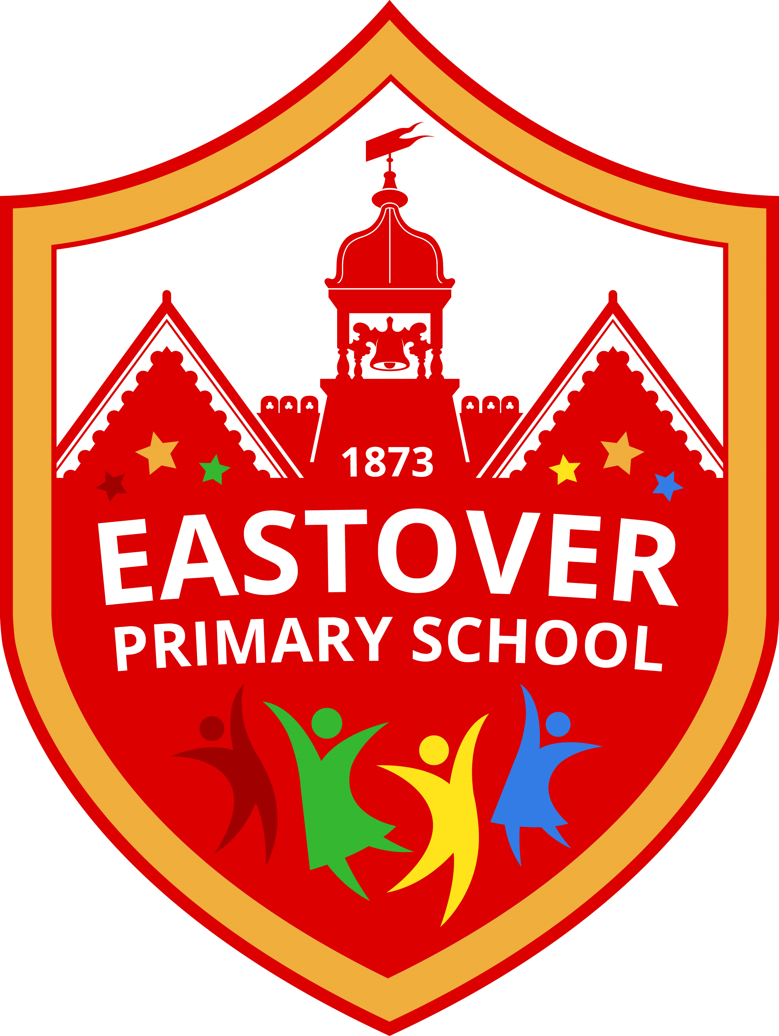

Approved by the Governing Body of
Eastover Primary School
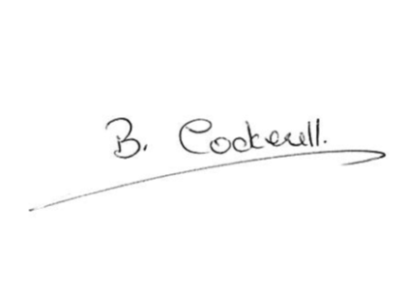

Name …Mrs B Cockrell…

Signature:

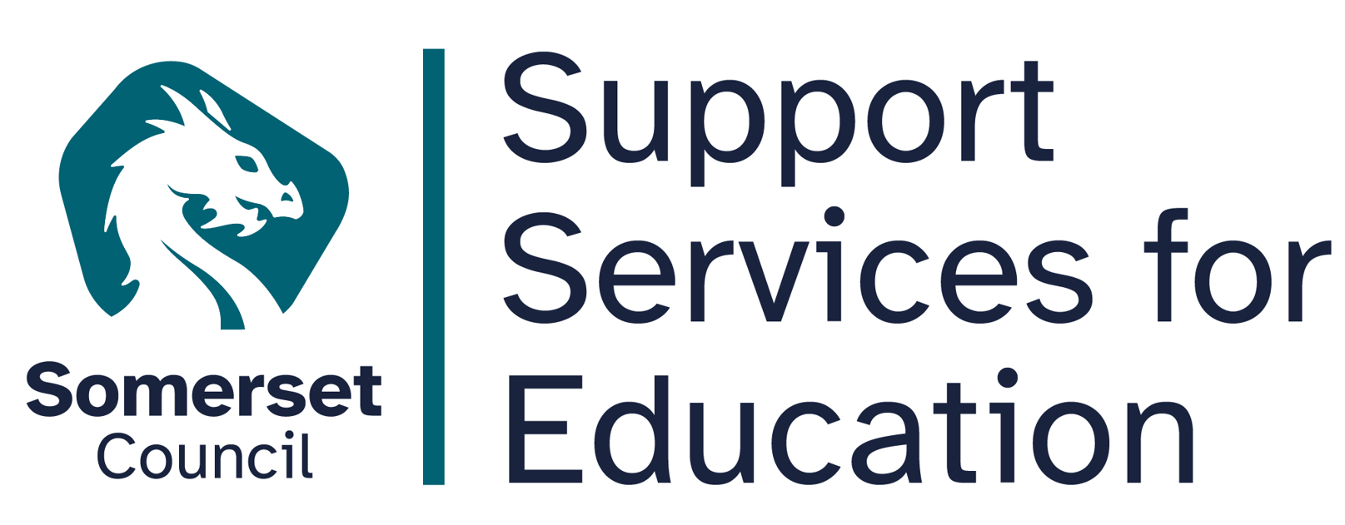

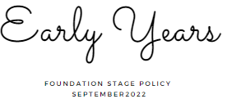
Member of staff responsible: Lynsey Irish
Date to be reviewed: January 2028

Early Years at Eastover Primary School
This document provides an overview of the policy, philosophy and practice in the EYFS at Eastover Primary School. It outlines our intentions in the EYFS and how we implement this within our provision.
At Eastover, all teaching staff deliver an EYFS curriculum through immersion in high quality teaching alongside an enriched environment.
Our philosophy is to nurture every child’s curiosity and enthusiasm for learning, developing both skills and confidence as they take their first steps on their own unique journey of lifelong learning.
““Every child deserves the best possible start in life and the support that enables them to fulfil their potential.”
(EYFS Framework, 2021)

This policy aims to ensure:
• That children access a broad and balanced curriculum that gives them the range of knowledge and skills needed for good progress through school and life.
• Quality and consistency in teaching and learning so that every child makes good progress and no child is left behind.
• A close working partnership between staff and parents and/or carers.
• Every child is included and supported through equality of opportunity and anti-discriminatory practice.

Legislation
This policy is written in accordance with the Statutory Framework for the Early Years Foundation Stage (September 2025).
Intent:
The intent for our children is to enter the next stage of their education ready to tackle new challenges with confidence and a positive growth mind-set.
ENGAGE our pupils in a stimulating environment led by the children yet carefully organised and managed by the adults. Providing a curriculum responsive to individual starting points and needs.
INNOVATE our children to take the lead in their own learning, encouraging confidence to explore new ideas, think about problems, take risks, make links and seek challenge.
DEVELOP high levels of engagement, curiosity, collaboration and cooperation. Highly adept at managing their own behaviour in the classroom and in social situations.
EXPRESS themselves with confidence in a meaningful way. Respecting the opinions and values of themselves and others.
“The education of even a very small child does not aim at preparing him for school but for life.”
Maria Montessori 1967

Implementation
Our approach is influenced by the work of educationalists, researchers, psychologists and practitioners who have guided our knowledge of how young children learn and how adults can support their learning. We appreciate that adult led learning offers a child something different from and complementary to child led learning and we believe that one without the other leads to a disadvantaged EYFS experience.
At Eastover provision is underpinned by a complementary relationship between adult led, adult initiated and child led learning. We are ambitious in our approach using a cycle of observation and assessment, planning/teaching, alongside structured and systematic lessons and group work.
Short focused groups are planned for writing, reading and maths and immediately follow a shared input. These sessions are planned with care, meeting the needs of all children, using prior knowledge of the child’s learning and experiences.
Indoors and outdoors resources are organised to develop children’s skills in personal interaction and exploration and are linked to current assessment data. Resources are carefully selected to meet the development needs of the children in order to enhance potential for new learning and consolidate prior learning. Resources are displayed to reflect children’s interests and/or current topic areas with discover, experiment and explore being key themes.
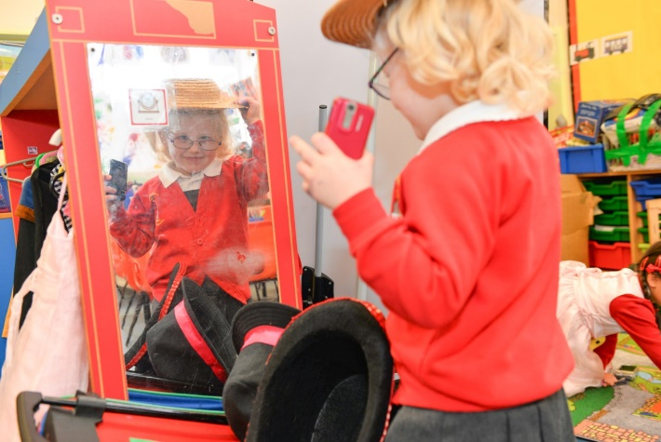
Continuous provision transcends all areas of learning and provides children with the opportunity to demonstrate the three characteristics of learning. Children are given the freedom to make independent choices and are encouraged to be active learners and take control of their own learning.

Impact
Children enter Key Stage One ready to begin the next chapter of their educational journey. They are equipped with a broad range of knowledge and skills that provide the right foundation for future progress through school and life.

The Curriculum
(Please see appendix A for Eastover Primary School EYFS Curriculum.)
The Eastover Primary School EYFS curriculum has been written in accordance with the latest version of the Statutory Framework for the Early Years Foundation Stage (September 2021, updated wording). Within this framework there are four guiding principles which shape our practice.
These are:
- Every child is a unique child, who is constantly learning and can be resilient, capable, confident and self-assured.
- Children learn to be strong and independent through positive relationships.
- Children learn and develop well in enabling environments with teaching and support from adults who respond to their individual needs and help them to build their learning over time. Children benefit from a strong partnership between practitioners and parents and/or carers.
- Children develop and learn at different rates. The Statutory Framework for the Early Years Foundation Stage covers the education and care of all children in early year’s provision including children with special educational needs and disabilities (SEND).
The Statutory Framework for the Early Years Foundation Stage (September 2021, updated wording) so includes seven areas of learning and development that are important and interconnected. Three areas are particularly important for building a foundation for igniting children’s curiosity and enthusiasm for learning, forming relationships and thriving. These are called the prime areas (in bold) and four other areas help children strengthen and apply the prime areas called the specific areas:
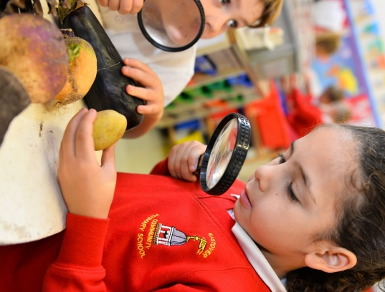
- Communication and language.
- Personal, social and emotional development.
- Physical development.
- Literacy.
- Mathematics.
- Understanding the world.
- Expressive arts and design.
We have developed the curriculum giving communication and language skills a high priority. This is in line with Development Matters 2020: “The development of children’s spoken language underpins all seven areas of learning and development. Children’s back-and-forth interactions from an early age form the foundations for language and cognitive development. The number and quality of the conversations they have with adults and peers throughout the day in a language-rich environment is crucial. By commenting on what children are interested in or doing, and echoing back what they say with new vocabulary added, practitioners will build children’s language effectively.”
A high priority is also given to the teaching of reading. We aim to teach children to read and develop a love of books as soon as they arrive at Eastover Primary School, and books are used to teach topics and to enhance our whole curriculum.
We follow a systematic approach to phonics teaching based on Unlocking Letters and Sounds.
We underpin our curriculum with the Personal Social and Emotional Development of all our children. We strive to enable children to be safe, happy, confident individuals. We also encourage self-regulation as much as possible and introduce rules and boundaries through modelling good behaviour and reflection time.
Throughout their time in the Reception year at Eastover our children partake in an ambitious curriculum is based around cross-curricular topics designed in a sequential way to ensure progress towards end of reception goals. These goals are defined as Early Learning Goals and the descriptors for these can be found in the Appendix. Each topic planned is included in the curriculum for specific reasons and we want to ensure that all children leave the Reception Year ready to start the Eastover KS1 curriculum. Each topic does not last a specific amount of time but is based on the children’s learning at the time, and so a topic can run from anything between two and seven weeks. All the topics have resources and activities ready to use in the enhanced provision. Topics are introduced with good quality storybooks or age-appropriate non–fiction text. Using books in this way teaches children that books and reading form the basis of all learning.

Teaching and Learning
Our curriculum incorporates learning through play, learning by adults modelling, by observing each other and through guided learning and direct teaching. It is also important to highlight that our plans are flexible to allow us to respond quickly to children’s new interests and/or needs. Weaving throughout the EYFS curriculum at Eastover Primary are three characteristics of effective teaching and learning. These are:
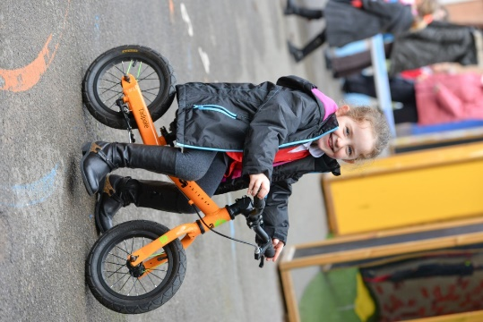
Playing and exploring – children investigate and experience things, and ‘have a go’.
Active learning – children concentrate and keep on trying if they encounter difficulties, and enjoy achieving.
Creating and thinking critically – children have and develop their own ideas, make links between ideas, and develop strategies for doing things.
These elements underpin how we reflect on each child’s development and adjust our practice accordingly. We support the children in their individual learning behaviours and talk with them daily. We believe observing the context of children’s play is essential.
“What children learn is important, but how children learn is even more important if they are to become learners in today’s society”
Helen Moylett
How children learn, Nancy Stewart 2011

Clear routines and consistent expectations support children to feel safe, secure and confident within the EYFS. Adults model positive behaviour and support children to develop self-regulation, resilience and independence through sensitive guidance, clear boundaries and reflective conversations.

The Role of the Adult in the EYFS at Eastover
Research shows that progress will be significantly enhanced by the effective support and role models of adults within a high quality learning environment. At Eastover the role of the adult particularly during continuous provision is based upon the work of Marion Dowling and her book on supporting sustained shared thinking (2005).
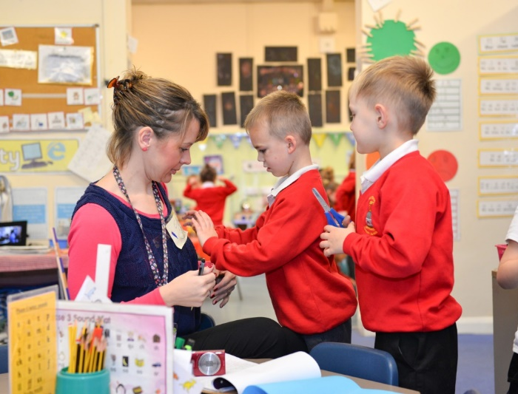
Within our setting interactions between adults and children will look like this:
- Tuning in to what is happening or a child’s thinking.
- Showing genuine interest.
- Respecting children’s own decisions and choices.
- Inviting children to elaborate.
- Recapping on what has happened so far.
- Offering personal experience.
- Clarifying ideas.
- Reminding.
- Using specific praise e.g. that is a good idea because…
- Offering an alternative viewpoint.
- Speculating/using ‘I wonder if…’
The definition of teaching in the EYFS as stated by Ofsted (2015);
Teaching should not be taken to imply a ‘top down’ or formal way of working. It is a broad term which covers many ways in which adults help young children learn. It includes their interactions with children during planned and child-initiated play and activities:
Communicating and modelling language, showing, explaining, demonstrating, exploring ideas, encouraging, questioning, recalling, and providing a narrative for what they are doing, facilitating and setting challenges.
It takes account of the equipment they provide and the attention to the physical environment as well as the structure and routines of the day that establish expectations. Integral to teaching is how practitioners assess what children know, understand and can do as well as take account of their interests and dispositions to learning (characteristics of effective learning) and use this to information to plan children’s next steps in learning and monitor their progress.
“A key role of the early childhood educator is to sustain children’s thinking and follow the momentum of their learning.”
(Julie Fisher, 2016)

The Role of the Environment in the EYFS at Eastover
The importance of each adult to support progression is crucial however, we equally understand that in times when a child is on their own independent learning journey the environment at Eastover plays a significant role in development.
“When it comes to what we have and where we have it, then nothing should be left to chance.”
(Alistair Bryce-Clegg, 2015)

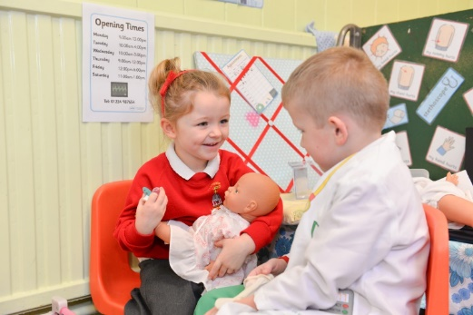
At Eastover, each area of the classroom is informed by assessment. As the needs of the children change, as they grow and develop, so does their learning space.
Using resources that are open ended encourage creativity, imagination and high order thinking skills. Using resources that can become anything and have unlimited potential.

Our timetable allows for long uninterrupted periods of continuous provision that allow the children time to reach a deep level of involvement as they engage, play, investigate and talk.

Shared Exploration of Language
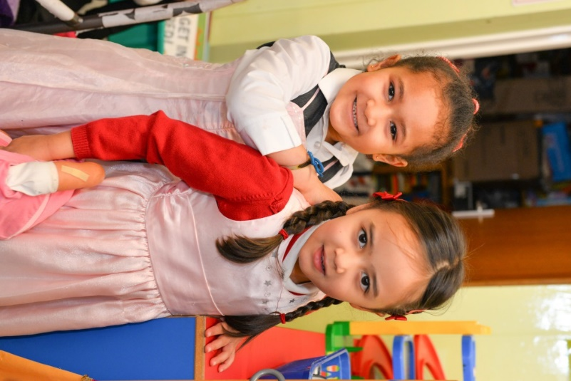
At Eastover, we believe the key to success is communication and language. Research clearly shows that they level of communication and language is the greatest predictor of success in later life.
Within the EYFS communication is a prime area of learning and at Eastover children use language to:
- Build strong relationships
- Communicate their ideas and their feelings
- Think creatively and critically
- As a tool for learning
- Become confident with the written word
The development of a young child’s communication and language comes primarily from tuning into conversations that are meaningful to the child. The preparation for all aspects of written language develops through one to one conversation with a responsive adult. Alongside quality interactions, rich and varied experiences ensure language provides the foundation of thinking and learning.

“It is through others that we develop into ourselves.”
(Lev Vygotsky 1981)

Improving young children’s vocabulary is paramount. Exploring and extending pupil’s vocabulary is part of everyday teaching in the EYFS at Eastover. Lessons are planned to enrich vocabulary and incidental opportunities are exploited.

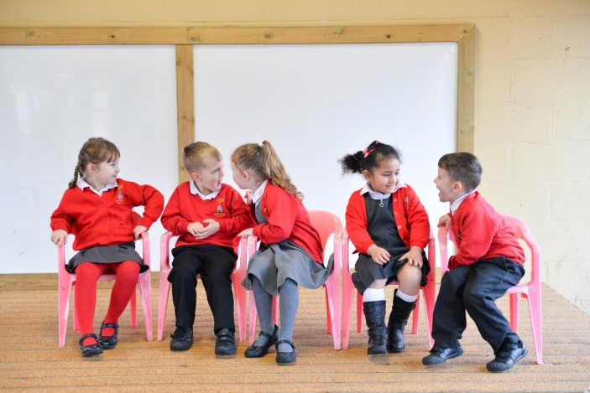
Our EYFS classrooms have a new words display which is used, referred to and added to in partnership with the children.
Texts are shared as a whole class daily. At Eastover, children are read to at least three times a day in addition to books provided for home reading which include a scheme book matched to their phonic ability, a choosing library book and a maths story. Children can select their library book from a wide range of genres including picture books, non-fiction information books and poetry.
The Million Word Gap
Young children who are read five books a day by the age of 5 have heard about 1.4 million more words than children who were never read to.
(Ohio State University 2019)

We share books with children for many reasons; enjoying stories together, linking with personal experiences, vocabulary building, developing imagination and language, learning about books. Listening to stories being read and re read helps children to gain insights into meaning and story structure.
Short guided reading sessions take place and texts are carefully chosen by staff to match the phonemes pupils are learning or about to learn.

Phonics in the EYFS at Eastover
Systematic synthetic phonics is taught using Unlocking Letters and Sounds.
Whole class or small group teaching takes place daily. Phase two begins at the start of FS at Eastover and children move through phase 2,3 and 4 throughout the year. Every phonics lesson incorporates the reading and writing of common exception words and high frequency words. Beginning in the EYFS children are taught how to segment words into phonemes and then how to segment and blend each phoneme.
Formative assessment takes place during all phonics lessons, quickly identifying who has and has not understood a new phoneme, grapheme or common exception word which then informs future planning. Summative assessment using Phonics Tracker takes place half –termly. Knowledge of each sound is checked, as well as the child being able to apply this when reading words. Pupils who are making slow progress are identified quickly and intervention is immediately put into place, alongside the usual phonics teaching.
Each phonics session is 15-20 minutes in duration and follows a teaching sequence which is implemented throughout the school ensuring transition to key stage 1 is seamless.

Writing in the EYFS at Eastover
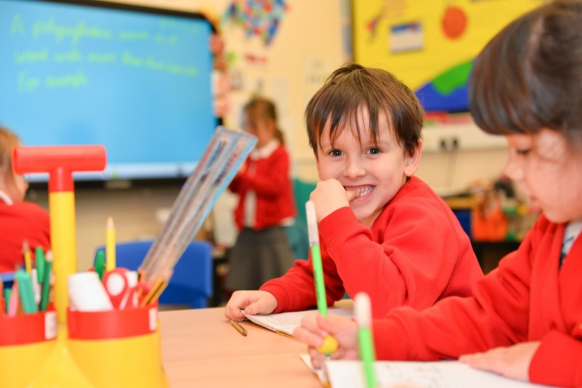
Mark making and speech provide children with powerful tools for thinking, reasoning and problem solving.
Throughout the day children have opportunities for spontaneous mark making, drawing and writing in both the indoor and outdoor environment. Resources are carefully chosen, well organised and attractively presented so that children the children can decide independently how they want to represent their ideas and which medium would best suit their purpose. High value is placed upon imagination, ideas and self-expression demonstrated by the children, these are reflected by the adults as starting points for planning.
On entry to reception children will often require much support when recording their ideas. At Eastover we support them as follows:
- Adults are dictated to by the child, the adult says each word as it is written.
- The children realise that groups of letters make up a word and a group of words make up sentences. The children then begin to write the initial sound of a word or a CVC word.
- Next more phonetically correct words are written by the child along with some common words such as ‘the’.
- Gradually the children take their pencil more and more independently until eventually they are writing complete phrases.
Handwriting development is our EYFS includes a wide variety of activities planned to develop the fine motor skills required for the correct pencil grip including threading, using tweezers, dough gym – the list is endless!

Maths in the EYFS at Eastover
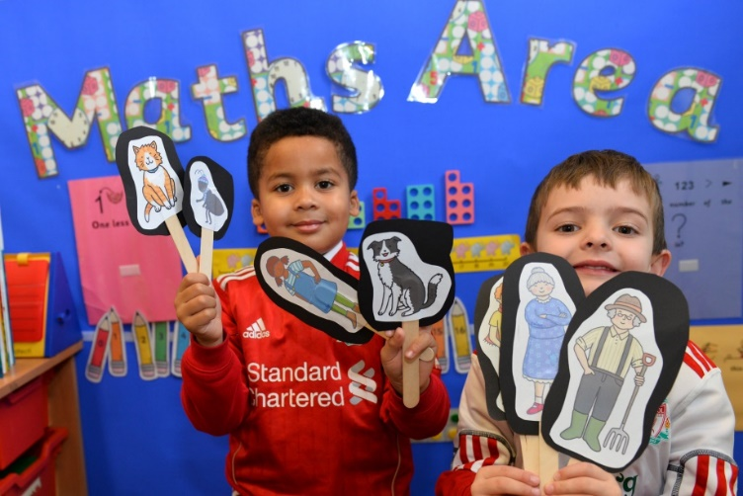
Children learn about maths through play and their daily experiences. Our setting is full of mathematical opportunities for children to explore, sort, compare, count, calculate and describe. Providing a safe environment to be creative, critical thinkers, problem solvers and to have a go.
Our objective is to ensure that all children develop firm mathematical foundations in a way that is engaging, and appropriate for their age. This means activity learning using resources and activities provided in the environment.
In addition, maths is explicitly taught daily as short whole class sessions and followed up with small group work.
Mastery of mathematical concepts in the EYFS takes the following approach:
Concrete – children use concrete objects and manipulatives to help them understand what they are doing.
Pictorial – children build on this concrete approach by using pictorial representations.
Abstract – with the foundations firmly laid, children move to an abstract approach using numbers and key concepts with confidence.

Assessment in the EYFS at Eastover
Within continuous provision our assessment strategy is 3-fold:
- Observation
- The Leuven Scales
- Summative Assessments
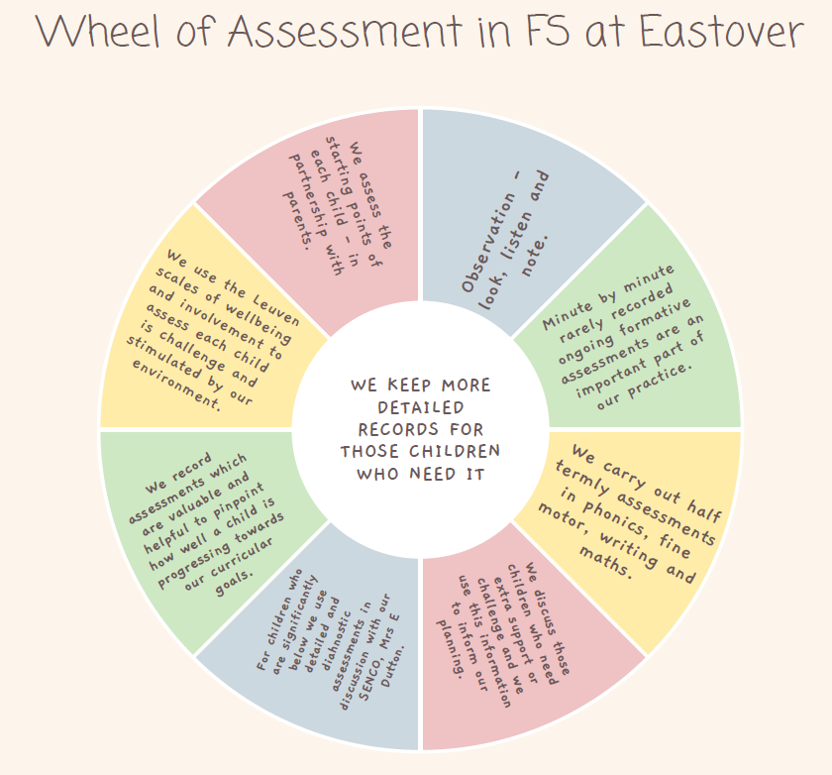
1.Observation
Throughout continuous provision observation forms a fundamental aspect of the pedagogy of EYFS at Eastover Primary School. Observation and responding to children’s thinking inform our planning of experiences and opportunities, how we create our environment for thinking, the strategies the adults use to extend learning (modelling, scaffolding, questioning, discussion, shared sustained thinking)and how we capitalise knowledge of children’s interests to ensure high levels of engagement.
2. The Leuven Scales
Alongside the use of observation as an assessment tool we rely upon the pioneering work of Professor Ferre Laevers (1980s) to understand how focused and comfortable our children are in our setting.
The scales of well-being and involvement act as a measure of deep learning and of the effectiveness of the learning environment. This has an empowering impact on our planning and can help to develop the huge potential of the children.
The 5 point scale measures:
Wellbeing refers to feeling at ease, being spontaneous and free of emotional tensions and is crucial to good mental health. It is linked to self-confidence, a good degree of self-esteem and resilience.
Involvement refers to being intensely engaged in activities and is a necessary condition for deep level learning and development. (These scales can be found in the appendix).
“High level attainment comes from high level engagement”
(Alistair Bryce-Clegg, 2015)

3.Summative Assessments
During the first term in Reception, the teacher assesses the ability of each child using a mixture of the statutory government baseline and also through teacher observations. These assessments allow us to identify patterns of attainment within the cohort, in order to adjust the teaching programme for individual children and groups of children. We record each child’s level of development throughout the year and record whether each child is on track or not on track to meet a Good Level of Development (GLD) at the end of the year in July.
Children will be judged at either an emerging level or an expected level in each early learning goal. The exceeding level no longer applies. We make regular assessments of children’s learning, and we use this information to ensure that future planning reflects identified needs. Assessment in the Foundation Stage takes the form of both formal and informal observations and through planned activities (see The Eastover EYFS Assessment wheel Appendix C). Assessment is completed regularly and involves both the teacher, teaching assistants, parents and children, as appropriate.
We record each child’s level of development throughout the year. At the end of the final term in Reception we assess whether each child is emerging or expected in each strand within each area of learning and submit this data to the local authority. This information is also shared with the child’s next teacher who uses this information to make plans for the year ahead. We share this information too at parental consultation meetings and in the end-of-year report.
Parents receive an annual written report that offers detailed comments on each child’s holistic progress across all areas of learning. It highlights the child’s strengths and development needs, and gives details of the child’s general progress. We complete these in June, and send them to parents in July each year.
Inclusion
All children will receive quality first teaching on a daily basis and activities will be differentiated accordingly. In addition to this, where children have been identified as having a specific need, intervention programmes will be implemented. Teachers and Teaching Assistants plan programmes together and where needed with liaison with the Special Needs Co-ordinator.
Equality and British Values
At Eastover Primary School, our EYFS provision promotes equality of opportunity, inclusion and anti-discriminatory practice in accordance with the Equality Act 2010. All children are supported to access the full breadth of the EYFS curriculum, and reasonable adjustments are made where necessary to ensure every child can participate fully, achieve well and feel a strong sense of belonging.
In line with Ofsted’s expectations, British Values are embedded through everyday practice in an age-appropriate way. Through positive relationships, carefully chosen texts, play-based learning and adult modelling, children are supported to develop an understanding of mutual respect, tolerance, fairness and kindness. These values are reflected in how children learn to listen to others, take turns, resolve conflict, respect differences and form positive relationships.
This approach supports children’s personal development, behaviour and attitudes, enabling them to become confident, respectful and caring members of the school community who are well prepared for life in modern Britain.
Structure
Safeguarding and welfare procedures
It is important to us that all children in the school are ‘safe’. We aim to educate children on boundaries, rules and limits and to help them understand why they exist. We provide children with choices to help them develop this important life skill. We help children to self-regulate and manage their emotions appropriately and Personal Social and Emotional Education is at the heart of everything we do.
Children should be allowed to take risks, but need to be taught how to recognise and avoid hazards. We aim to protect the physical and psychological well-being of all children. We know that children learn best when they are healthy and safe, when their individual needs are met and when they have the chance to build positive relationships with the adults around them and their peers.
The rest of our safeguarding and welfare procedures are outlined in our suite of safeguarding policies which have been written in accordance with ‘Keeping Children Safe in Education (September 2024). Our Designated Safeguarding Lead is Mrs Sarah Stacey. Where attendance or punctuality becomes a concern, staff work proactively with families and the wider school to support regular attendance and early intervention. Staff follow up any unexplained or prolonged absence promptly in line with safeguarding requirements, working with families and the wider school to ensure children’s welfare and safety.

Safeguarding Training
All staff receive regular safeguarding training, which is updated in line with statutory guidance, and are supported to apply this consistently in practice.

Whistleblowing

Clear whistleblowing procedures are in place to enable staff to report concerns about the conduct or behaviour of adults working with children, without fear of reprisal.

Personal Care and Children’s Privacy
Children’s privacy and dignity are respected during toileting and personal care routines, while maintaining appropriate safeguarding oversight at all times.

Safer Recruitment
Recruitment procedures follow safer recruitment practice to ensure that only suitable adults work with children.

Emergency Contact Information
Up-to-date emergency contact details are held for all children, including additional contacts where required.

Nutrition and Health
The school takes account of the latest early years nutrition guidance to promote children’s health and wellbeing. We are a healthy school and participate in the free fruit and milk for under-fives scheme. For our Reception children we provide the universal infant free school meal and the menu is regularly monitored with the chef. We cater for those children who have special dietary requirements and EYFS have robust systems in place ensuring that all children receive the correct meal. We make sure that children with allergies or other dietary requirements are catered for in conjunction with our catering providers.
Fresh water is readily available for all children and we encourage children to bring in drink bottles/cups so that they can help themselves to water at any time.
At Eastover Primary School, we meet the statutory requirements for paediatric first aid set out in the Early Years Foundation Stage statutory framework (September 2025). At least one member of staff with a current full Paediatric First Aid (PFA) qualification is on the premises and available at all times when children are present and accompanies children on outings. Staff included in staff-to-child ratios, including apprentices, students on long-term placements, volunteers and staff qualified through the experience-based route, hold a valid PFA qualification where required. Paediatric first aid certificates are kept up to date and renewed in line with statutory guidance, ensuring children’s safety and welfare remain a priority at all times.

Structure and Staffing of the EYFS
The EYFS at Eastover Primary consists of two Reception Classes. The Reception Classes are taught by qualified primary school teachers. Both teachers have a vast experience teaching young children.
Each class also has a full time, experienced EYFS teaching assistant.
Specialist teachers are brought in for weekly PE lessons delivered by Champion Sports and Events.
Children can arrive into the classroom at 8:35am every morning and children are picked up at 3.15pm.
The children have lunch and breaks with the other KS1 children. The class join the main school for assemblies and other whole school events.
Extra teaching assistants are employed for children who have an Education Health and Care Plan.
Staff working within the EYFS receive regular professional development to ensure they have a secure understanding of the EYFS framework, child development, safeguarding and inclusive practice. Leaders support and monitor the quality and consistency of teaching, interactions and provision to ensure that all children benefit from high-quality early education.

Parental Involvement
We recognise that parents/carers are children’s first educators and we value having a positive relationship with them in their child’s education through:
✓ Making contact with parents/carers before their child starts school at our parent walkabouts, induction sessions, welcome packs and nursery visits.
✓ Inviting parents/carers and children the to attend an induction meeting in the summer term.
✓ Inviting parents to phonic, reading and maths workshops to see how their children will begin learning and how they can support them.
✓ Operating an open-door policy for parents/carers with any queries or concerns. Conversely, if EYFS staff have concerns about the progress of a child, they will approach parents and carers to discuss them.
✓ Written contact through reading records and weekly review newsletters.
✓ Sharing photos, updates and ‘wow moments’ on Seesaw (our online communication and home learning platform).
✓ Offering two, parent-teacher consultation meetings per year at which their child’s progress and wellbeing is discussed.
✓ Sending a written report on their child’s attainment, progress and attitude at the end of their time in reception.
✓ Asking parents to sign a generic permission form for visits, food-tasting and photographs etc.
✓ Parents are invited to a range of activities throughout the school year such as special events, workshops, Christmas crafts, Christmas productions and sports day etc.
✓ Offering opportunities for parents and carers to visit the school as a volunteer to assist with the children’s learning e.g. hearing readers.

Transition
Starting school can be a difficult time for young children; we therefore plan this time carefully to support children with the transition and to ensure it is as smooth as possible for each child and that they settle in to their new class quickly and happily.
We have a tried and tested induction programme which includes:
- An induction meeting for parents so that teachers can get to know parents and carers and ask about the individual children. The teacher gives parents practical information such as the ethos of the school, vision and values, information about equipment and uniform needed.
- Stay and plays at the start of term so that the children can get to know the teachers and school staff without their parent present.
- A gradual introduction to the school day. Children begin with a reduced timetable. This introduces the children to their new routines gradually and this enables children to be less over whelmed.
When children transition into year 1 the teacher has time with the year 1 teacher to give them all the relevant welfare, academic and general information about all the children leaving the EYFS. The Year 1 teacher shares a story with the Reception children once a week in the last half of the summer term so the children can start to get to know them. One of these sessions is done in the year 1 classroom so that the children see their new classroom before the summer holidays.

Appendix A – Eastover Reception Long Term Curriculum

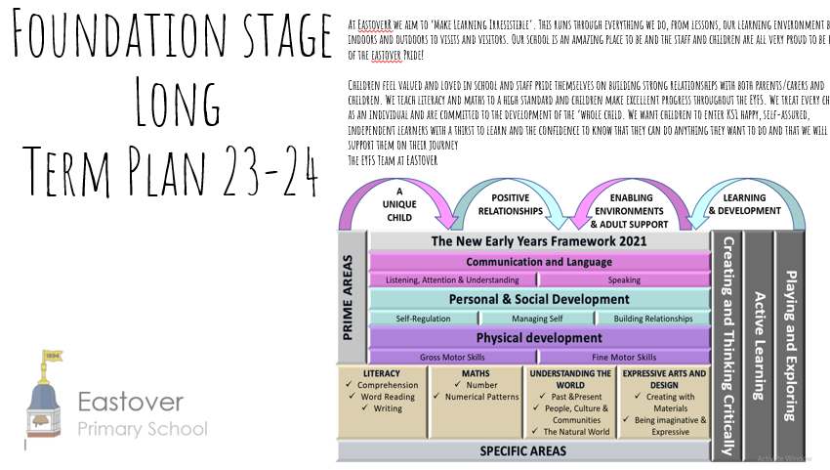
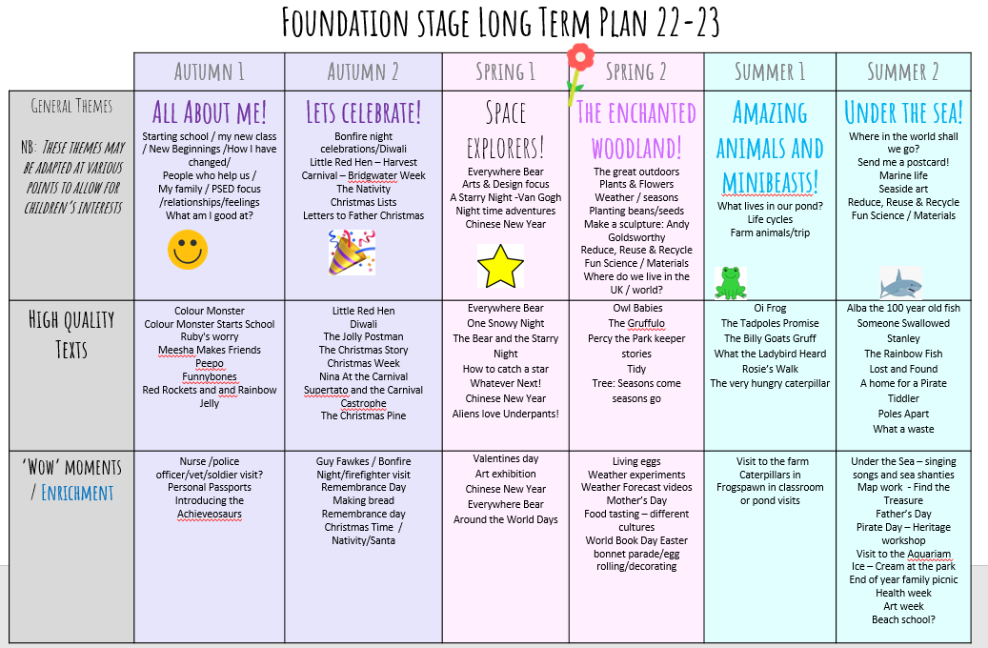
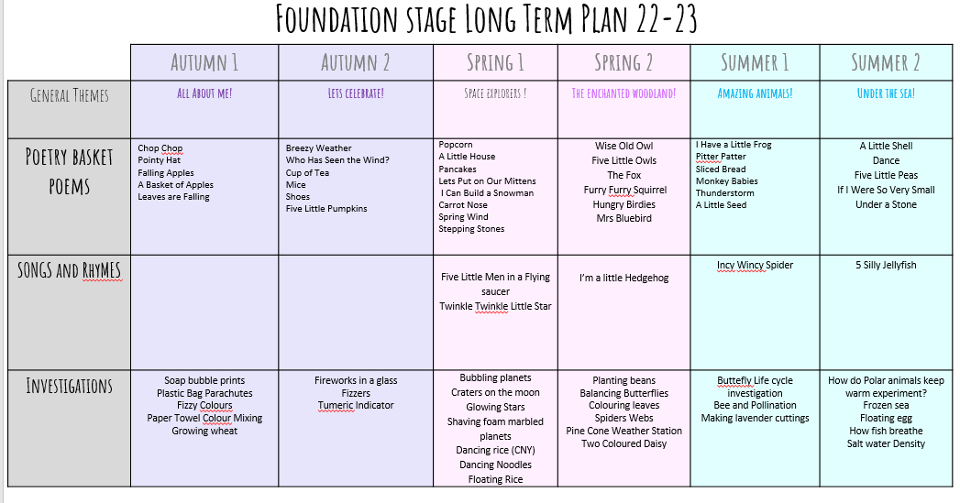

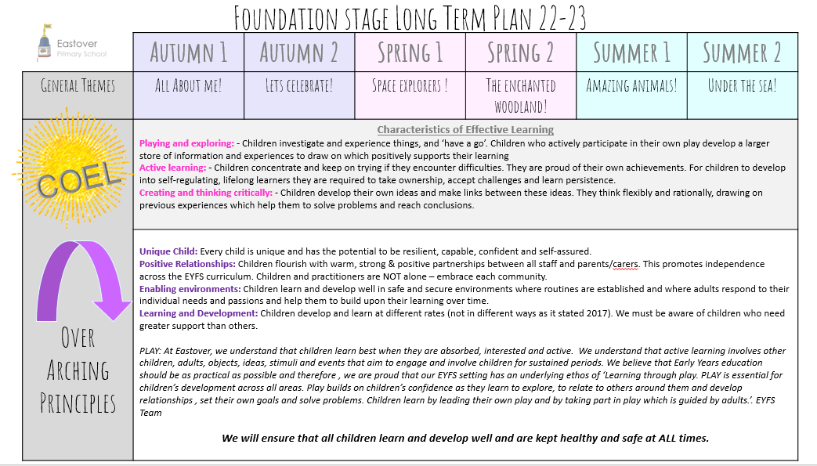

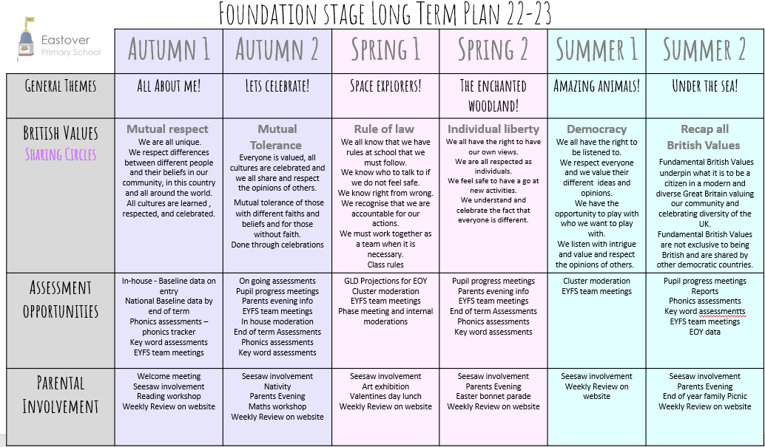

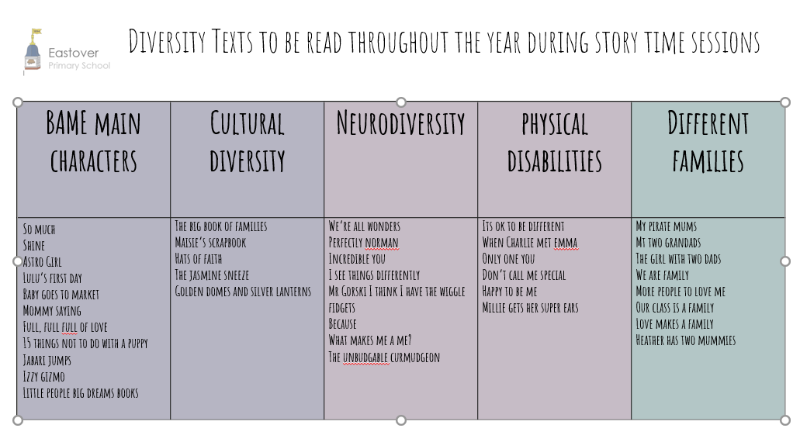

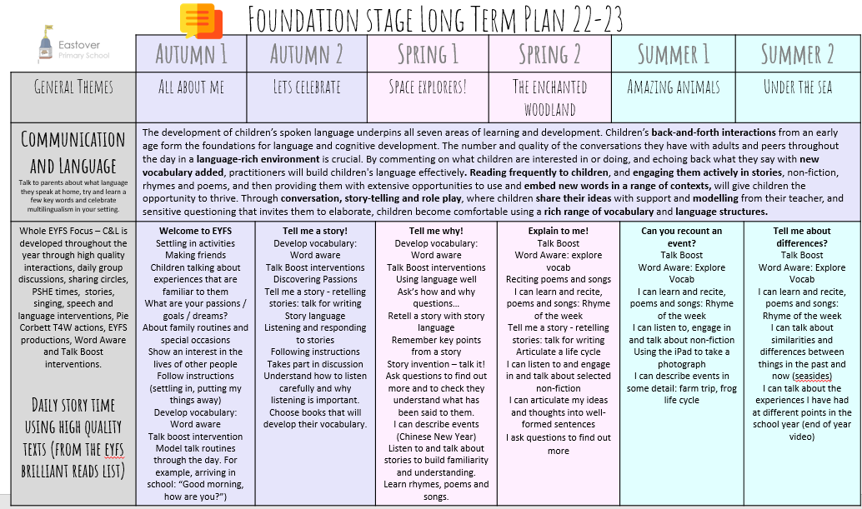

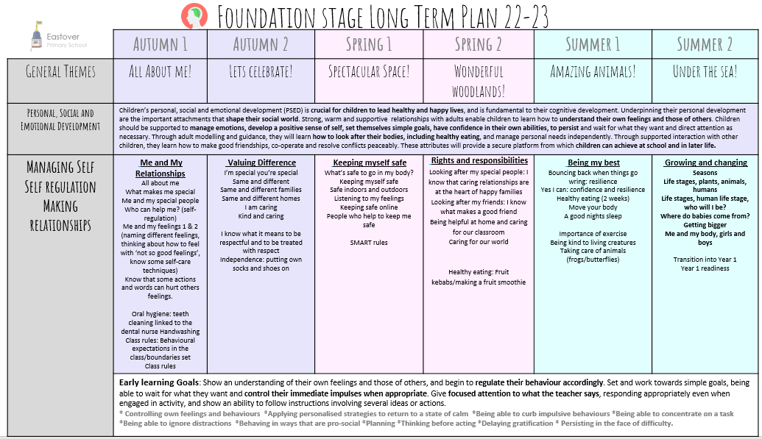

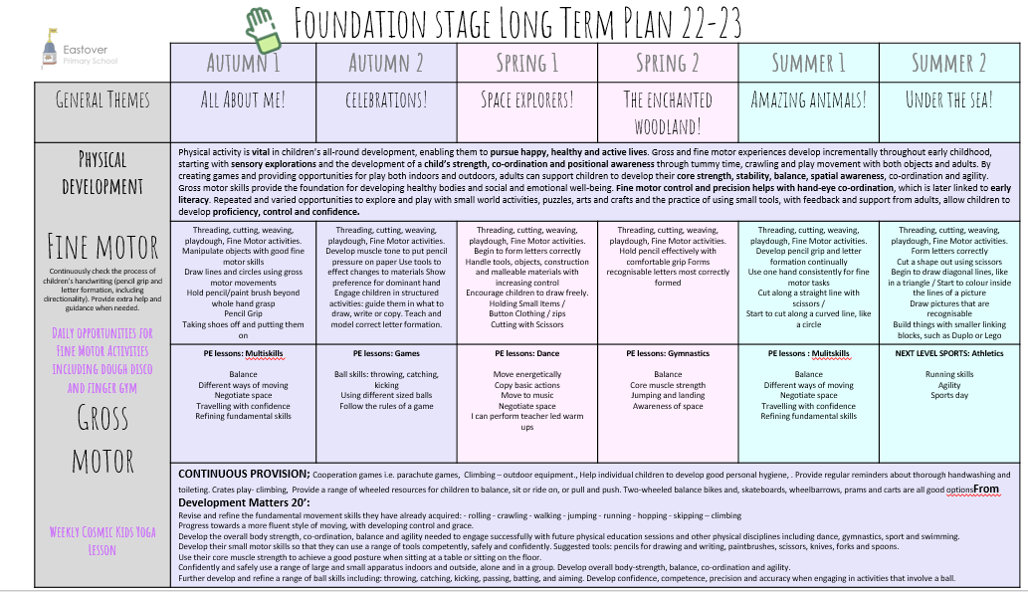

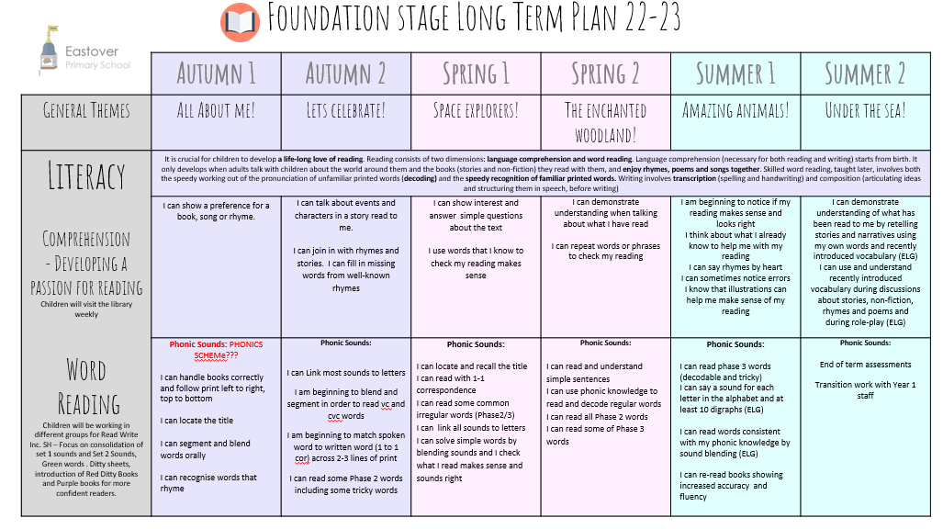

Communication and Language
Listening, Attention and Understanding
- Listen attentively and respond to what they hear with relevant questions, comments and actions when being read to and during whole class discussions and small group interactions.
- Make comments about what they have heard and ask questions to clarify their understanding.
- Hold conversation when engaged in back-and-forth exchanges with their teacher and peers.
Speaking
- Participate in small group, class and one-to-one discussions, offering their own ideas, using recently introduced vocabulary.
- Offer explanations for why things might happen, making use of recently introduced
vocabulary from stories, non-fiction, rhymes and poems when appropriate.
- Express their ideas and feelings about their experiences using full sentences, including use of past, present and future tenses and making use of conjunctions, with modelling and support from their teacher.
Physical Development
Gross Motor Skills
- Negotiate space and obstacles safely, with consideration for themselves and others.
- Demonstrate strength, balance and coordination when playing.
- Move energetically, such as running, jumping, dancing, hopping, skipping and climbing.
Fine Motor Skills
- Hold a pencil effectively in preparation for fluent
writing – using the tripod grip in almost all cases.
- Use a range of small tools, including scissors, paintbrushes and cutlery.
- Begin to show accuracy and care when drawing.
Personal, Social and Emotional Development
Self-Regulation
- Show an understanding of their own feelings and those of others, and begin to regulate their behaviour accordingly.
- Set and work towards simple goals, being able to wait for what they want and control their immediate impulses when appropriate.
- Give focused attention to what the teacher says, responding appropriately even when engaged in activity, and show an ability to follow instructions involving several ideas or actions.
Managing Self
- Be confident to try new activities and show independence, resilience and perseverance
in the face of challenge.
- Explain the reasons for rules, know right from wrong and try to behave accordingly.
- Manage their own basic hygiene and personal needs, including dressing, going to the toilet and understanding the importance of healthy food choices.
Building Relationships
- Work and play cooperatively and take turns with others.
- Form positive attachments to adults and friendships with peers.
- Show sensitivity to their own and to others’ needs.
Appendix B - 17 Early Learning Goals – EYFS

Understanding the World
Past and Present
- Talk about the lives of the people around them and their roles in society.
- Know some similarities and differences between things in the past and now, drawing on their experiences and what has been read in class.
- Understand the past through settings, characters and events encountered in books read in class and storytelling.
People, Culture and Communities
- Describe their immediate environment using knowledge from observation,
discussion, stories, non-fiction texts and maps.
- Know some similarities and differences between different religious and cultural communities in this country, drawing on their experiences and what has been read in class.
- Explain some similarities and differences between life in this country and life in other countries, drawing on knowledge from stories, non-fiction texts and (when appropriate) maps.
The Natural World
- Explore the natural world around them, making observations and drawing pictures of animals and plants.
- Know some similarities and differences between the natural world around them and contrasting environments, drawing on their experiences and what has been read in class.
- Understand some important processes and changes in the natural world around them, including the seasons and changing states of matter.

Literacy
Comprehension
- Demonstrate understanding of what has been read to them by retelling stories and narratives using their own words and recently introduced vocabulary.
- Anticipate (where appropriate) key events in stories.
- Use and understand recently introduced vocabulary during discussions about stories, non- fiction, rhymes and poems and during role play.
Word Reading
- Say a sound for each letter in the alphabet and at least 10 digraphs.
- Read words consistent with their phonic knowledge by sound-blending.
- Read aloud simple sentences and books that are consistent with their phonic knowledge, including some common exception words.
Writing
- Write recognisable letters, most of which are correctly formed.
- Spell words by identifying sounds in them and representing the sounds with a letter or letters.
- Write simple phrases and sentences that can be read by others.

Mathematics
Number
- Have a deep understanding of number to 10, including the composition of each number.
- Subitise (recognise quantities without counting) up to 5.
- Automatically recall (without reference to rhymes, counting or other aids) number bonds up to 5 (including subtraction facts) and some number bonds to 10, including double facts.
Numerical Patterns
- Verbally count beyond 20, recognising the pattern of the counting system.
- Compare quantities up to 10 in different contexts, recognising when one quantity is greater than, less than or the same as the other quantity.
- Explore and represent patterns within numbers up to 10, including evens and odds, double facts and how quantities can be distributed equally.

Expressive Arts and Design
Creating with Materials
- Safely use and explore a variety of materials, tools and techniques, experimenting with colour, design, texture, form and function.
- Share their creations, explaining the process they have used.
- Make use of props and materials when role playing characters in narratives and stories.
Being Imaginative and Expressive
- Invent, adapt and recount narratives and stories with peers and
their teacher.
- Sing a range of well-known nursery rhymes and songs.
- Perform songs, rhymes, poems and stories with others, and (when appropriate) try to move in time with music.

Appendix C – Wheel of Assessment in EYFS at Eastover

Appendix D – Leuven Scales


